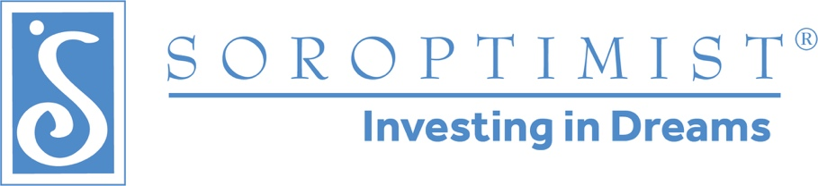

January 13, 2020
Soroptimist International of Davis
Community Grant application form
Our mission: Soroptimist is a global volunteer organization that provides women and girls with access to the education and training they need to achieve economic empowerment.
SI Davis’ major fundraiser is selling beer and wine at the Davis Farmers Market. Each year, it reinvests those profits in its programs and projects. These include Live Your Dream: Education and Training Awards for Women, and Dream It, Be It: Career Support for Students at King High School. It also funds high school scholarships, community grants to nonprofits, and anti-trafficking efforts.
In 2020, the club has $6,500 budgeted for community grants of up to $2,500 each. Nonprofit organizations that align with the Soroptimist mission are encouraged to apply. The deadline is March 6. Awards will be handed out April 30 at the club’s Dream Awards Night.
Grant applications will be assessed based on their alignment with the Soroptimist mission, community impact and feasibility. Any organization, including previous recipients, is encouraged to apply. This is a competitive grant process.
Applicants will receive notice by April 1 of the status of their application. There are three ways to apply:
1. Fill out the application at https://www.sidavis.org/grants and submit directly
2. Download the Word doc and fill it out. Email the completed file as an attachment (in Word or converted to a pdf) to sidavis@soroptimist.net with the subject line "2020 Grant Application." Add your name and contact information in the body of the email.
3. Download the Word doc, fill it out, and mail a paper copy it to SI Davis, PO Box 472, Davis, CA 95617, Attn: Grant Applications.

Organization’s name

Phone

Email

Amount requested (up to $2,500)

What is your organization’s mission?

Describe the project/program you would like SI Davis to help fund.

How would this project/program help women and girls in Yolo County?

Does the amount requested cover the cost of the proposed program? If not, what other sources of funding will be used?

Please give a brief description/budget of how the grant funds would be used.

If your organization is selected, how can we mutually share in public awareness of this Community Grant?

